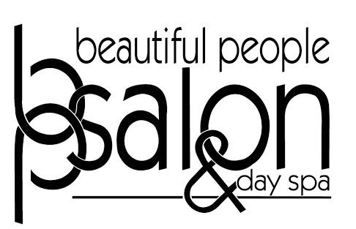

Post-Quarantine Color Consultation Questions

Hair History
1.Do you have any allergies/skin conditions we need to know about?
____________________

2.How long has it been since your last hair service? __________

3.What type of services have you received in the past year? 3 months?
- Haircut:
- Color services:
- Smoothing services:
- Other chemical services:

Hair maintenance
1.How often do you normally wash your hair?____________ How often have you been washing during quarantine? _______________________
Did you notice a difference? Yes __ No __

2.What products have you been using at home?
- Shampoo:
- Conditioner:
- Styling Aids:
3.How do you prefer your hair to be styled? (check all that apply)
- Air-dried __
- Blow-dried, not styled __
- Sleek and smooth __
- Wavy __
- Curly __
- Up __
- Down __
Do you feel successful styling it yourself? If you could change anything about your hair, what would it be?

Recent History
1.Have you had any NEW allergies or skin conditions arise since your last visit? ____________________
2.If you have not had your hair colored since your last visit:
- How long has it been?____________________
- What was that service?____________________
- Do you have grey hair?____________________
- Is your hair colored to a lighter color?____________________
- Do you have highlights/balayage?____________________
- Has your color faded more than normal?____________________
- How do you feel about the color on the ends?____________________
- Are you looking for a change from what you had done at your last service? __________
- .
3.We promise zero judgments! Your honest answer is imperative to properly and safely schedule your next visit. If you have colored your hair yourself since your last visit:

a. What type of color did you use?
- Permanent ___
- Semi-permanent ___
- Other/Not sure ___
b. What brand was it? ____________________
c. Did it cover your grey?
- Yes ___
- No ___
- I don’t have grey that needs covered ___
d. How did it turn out?
- It matches! __
- It’s pretty similar, but the grey didn’t cover. __
- It’s lighter/brighter. __
- It’s darker. __
- I had highlights/balayage before, but now I don’t __

Notes or Comments
Please add any notes or comments you feel we should be aware of that was not included in this questionnaire below.

Your Next Appointment
1. What services will you need at your next appointment? Check all that apply:
- Haircut __
- Single Process color (your roots) __
- Highlights __
- Balayage __
- Toner __
- Smoothing Treatment __
- Other chemical service __
- I have no idea __

2. Do you have any new goals since the last time you were in the salon? ________________________________________

3.Are you available for a FaceTime/Zoom consultation if we feel we need more info?
- Yes, I’m available ____________________
- No, I would prefer a Phone call
a. Please provide best phone contact number to reach you and the best time to call.

You are welcome to complete the Questionnaire as best you can although this is a designed to help facilitate your consultation and give you an understanding of what information we might need.

Thank-you for understanding how important it is at this time that we can adjust our scheduling in order to accommodate proper social distancing and sanitation procedures.

